**Hot Pursuit NEO Tracking Automation**

I’m thinking we should have a category called “101 Fun Things To Do With TheSky. This little application mostly falls under that moniker. As most of us know, a couple of hundred good sized rocks are discovered whizzing by the earth every year. Today, most of these Near Earth Objects (NEO’s) are identified by well-funded, organized projects, but a few are still by amateurs, here and there. However once spotted, each reported fly-by goes through a phase where it must be confirmed and a precise orbit determined through multiple, independent measurements. During its time in purgatory, a NEO is listed on a NASA website called “Scout”. Once confirmed (by somebody, at some point, I guess) the object moves off of Scout and into the IAU Minor Planet Center database. But, for a time, one has a chance for a look at the equivalent of an astronomical UFO. That’s where this little app comes in.

Hot Pursuit partners with another TSXToolKit app called Transient Search. Transient Search enables a user to load the current Scout unconfirmed object list into TSX as a SDB catalog in about three clicks. (This too falls under the category of “101 Fun Things...”). Once loaded a user can pick a target and run Hot Pursuit whose sole job is to keep the mount pointed at that target. The reason it’s tricky is that these NEO’s move across the sky at a pace and direction somewhere between a satellite and a planet. At any given time, their apparent movement is anywhere between less than one to over a couple of hundred arcsec/min -- and the drift continuously changes in apparent speed and direction.

So what Hot Pursuit does is get the current ephemeris information from Scout, then recalculates and interpolates the position and speed in down to one second tracking instructions for the imager’s site. That calculation is passed to TheSky in the form of real-time Tracking Speed changes over the course of the session. The user is free to use whatever imaging technique they prefer: long exposure, stacking, live stacking, video, etc, but I did drop in a quick and dirty, one-click imaging controller just for the inherently lazy like myself.

Imaging can be a challenge – these objects are dim, normally a few magnitudes plus or minus of 20. The other challenge is that the Scout ephemeris is no better than the quality of the initial orbital observations – which can just be bad sometimes. There are times when you could be taking pictures of empty space – yeah, a bit of a crapshoot. But when it works, it’s kind of cool to catch the little guy tumbling along waiting to smack into something.

But wait, there’s more. While developing this, I found that having the capability of looking at previously confirmed rocks and ice was useful to build my confidence that everything was working correctly. So, I also built in a feature where one could acquire ephemeras from the NASA Horizons or IAU Minor Planet Center database as well. Simply use TheSky to select a target from the Small Solar System Body database, or just enter a name designation in the Target field to select. For instance, if you wanted to image the James Webb, simply enter “JWST” in the target field and hit “Horizons” to load and initiate TheSky tracking. Naming conventions seem to differ between the two databases, so if one doesn’t work, try the other. For instance, the MPC database seems more amenable to successful searches on target designations such as found in TheSky.

Of recent vintage is the Plot feature. Using Plot creates a dataset that is loaded to the clipboard for input to TSX. This dataset tells TSX to plot the position of the selected target on the StarChart over a span of days.

**Overview**

Installation

1. After each update, run TheSky once (and only once) in Administrator Mode to register its interface libraries.
2. From <https://github.com/rrskybox/TransientSearch/tree/master/publish>, download *TransientSearch.zip*, extract all files and open “*setup.exe*”.
3. From <https://github.com/rrskybox/Hot-Pursuit/tree/master/Hot%20Pursuit/publish> , download *HotPursuit64.zip*, extract all files and open “*setup.exe*”.

Preparation

1. From the TSXToolKit in the Start Menu: Launch *Transient Search*.
2. In Transient Search, in MPC NEO box, check “*Scout*” and select “*NEO*”. Close Transient Search.
3. Launch *TheSky64*.
4. In the TheSky, Select *Edit->Paste Photo*. Answer “yes” to opening SDB.

Operation

1. In TheSky, pick (left click on) a NEO asteroid from the Sky Chart.
2. Launch *Hot Pursuit*.
3. In Hot Pursuit, select “*Pursue*”.
4. In Hot Pursuit, configure QAD Imaging and click on *Image*

or

1. In theSky64: Image to taste.
2. View image in inverse to pick out target (suggested).

Hot Pursuit is a Windows 10 desktop application whose purpose is to automate the tracking of a NEO object with TheSky.

Targets are normally input to TheSky using the *TSXToolKit Transient Search* application via the NEO Scout search. The user selects one then launches Hot Pursuit. As an alternative, the ephemeris of any small body, asteroid or comet, can be designated in TheSky (or input in the Target field) and updated/tracked via the Horizons database.

Hot Pursuit fetches the name of the current TSX target, queries the CNEOS Scout, MPC or Horizons web site for its current ephemeral data, slews the mount to the coordinates and changes the tracking to match the target’s pace. Hot Pursuit recaptures the ephemeral data and resets tracking speeds every few minutes as set by the user. In the case of a satellite target, the CelesTrak web database will be queried for a current TLE, which is then submitted to Horizons for conversion into the ephemeris table.

**Controls, Fields and Commands**

Target: This field is filled with the name of the target currently picked by the user in TheSky. The user can type in a target name in this field directly, or, if the field is empty, Hot Pursuit will use the currently selected target (Find Function) in TheSky. Double-clicking in the Target field will clear the current contents, unless tracking is in progress.

RA Rate: Rate of change in arcsec per minute of RA, corrected for the observer’s location.

Dec Rate: Rate of change in arcsec per minute of Dec, corrected for the observer’s location.

Range: Distance to the target in AU.

Scout: Enables Scout web database query and tracking for the entered target.

Horizons: Enables Horizons web database query and tracking for the entered target.

MPC: Enables MPC web database query and tracking for the entered target.

Plot: Days: Number of days to plot the position of this target on the TSX StarChart (see below).

Plot: Generate SDB: The respective database will be queried for the position of the target over the following days and the returned dataset will be loaded in the clipboard. Subsequently, applying the Edit->Paste Photo database loading function in TSX will load the clipboard to produce a plot on the Star Chart of the target’s position over that time.

Refresh: Sets the rate at which the updates TheSky tracking with new ephemeris rate data. The minimum period for ephemeris from Scout is 1 minute. If min is selected, then the period is in minutes. If sec is selected, then the Refresh period will be in seconds. If in seconds, Hot Pursuit will interpolate the downloaded target rate data at the period set by the Refresh period.

Next Refresh: Number of seconds until the next time Hot Pursuit will update the tracking change to TheSky.

CLS: If checked, a Closed Loop Slew will be used to iniitially point to the target. Otherwise a simple slew will be used.

On Top: Causes the Hot Pursuit window to stay on top of all other windows.

Track: Initiates ephemeris query followed by the non-sidereal tracking for the entered target. Tracking is updated at per the Refresh period. Clicking on Track when the background is red cancels the non-sidereal tracking updates, and aborts imaging (if active), but does not close the program

Trail: Turns on the main camera autoguiding using the brightest star found in the camera image which can keep the target centered during inaccurate tracking.

Close: Closes the program.

QAD Imaging: These fields and commands are provided for simple one-shot imaging using automation of TheSky.

Exposure: Length in seconds of image to be taken.

Filter: Drop down box for choosing the filter to be used for imaging from the list of filter wheel filter names.

Reps: Number of images to take sequentially.

Recenter: If checked, Hot Pursuits will perform a Closed Loop Slew to the current target coordinates before each image exposure. This feature ensures the target remains locked to the center of every image identically for every shot. This feature is especially useful for unregistered image stacking.

Reduce: Turns on full image reduction. See below for details of preparation.

Image: Initiates imaging using TheSky.

Status Box: This area contains log information about what’s going on under the covers. This information is also stored in a text file found in the user’s Documents directory folder “Hot Pursuit” in the “Log” directory under a filename “<date>.txt”.

**Structure**

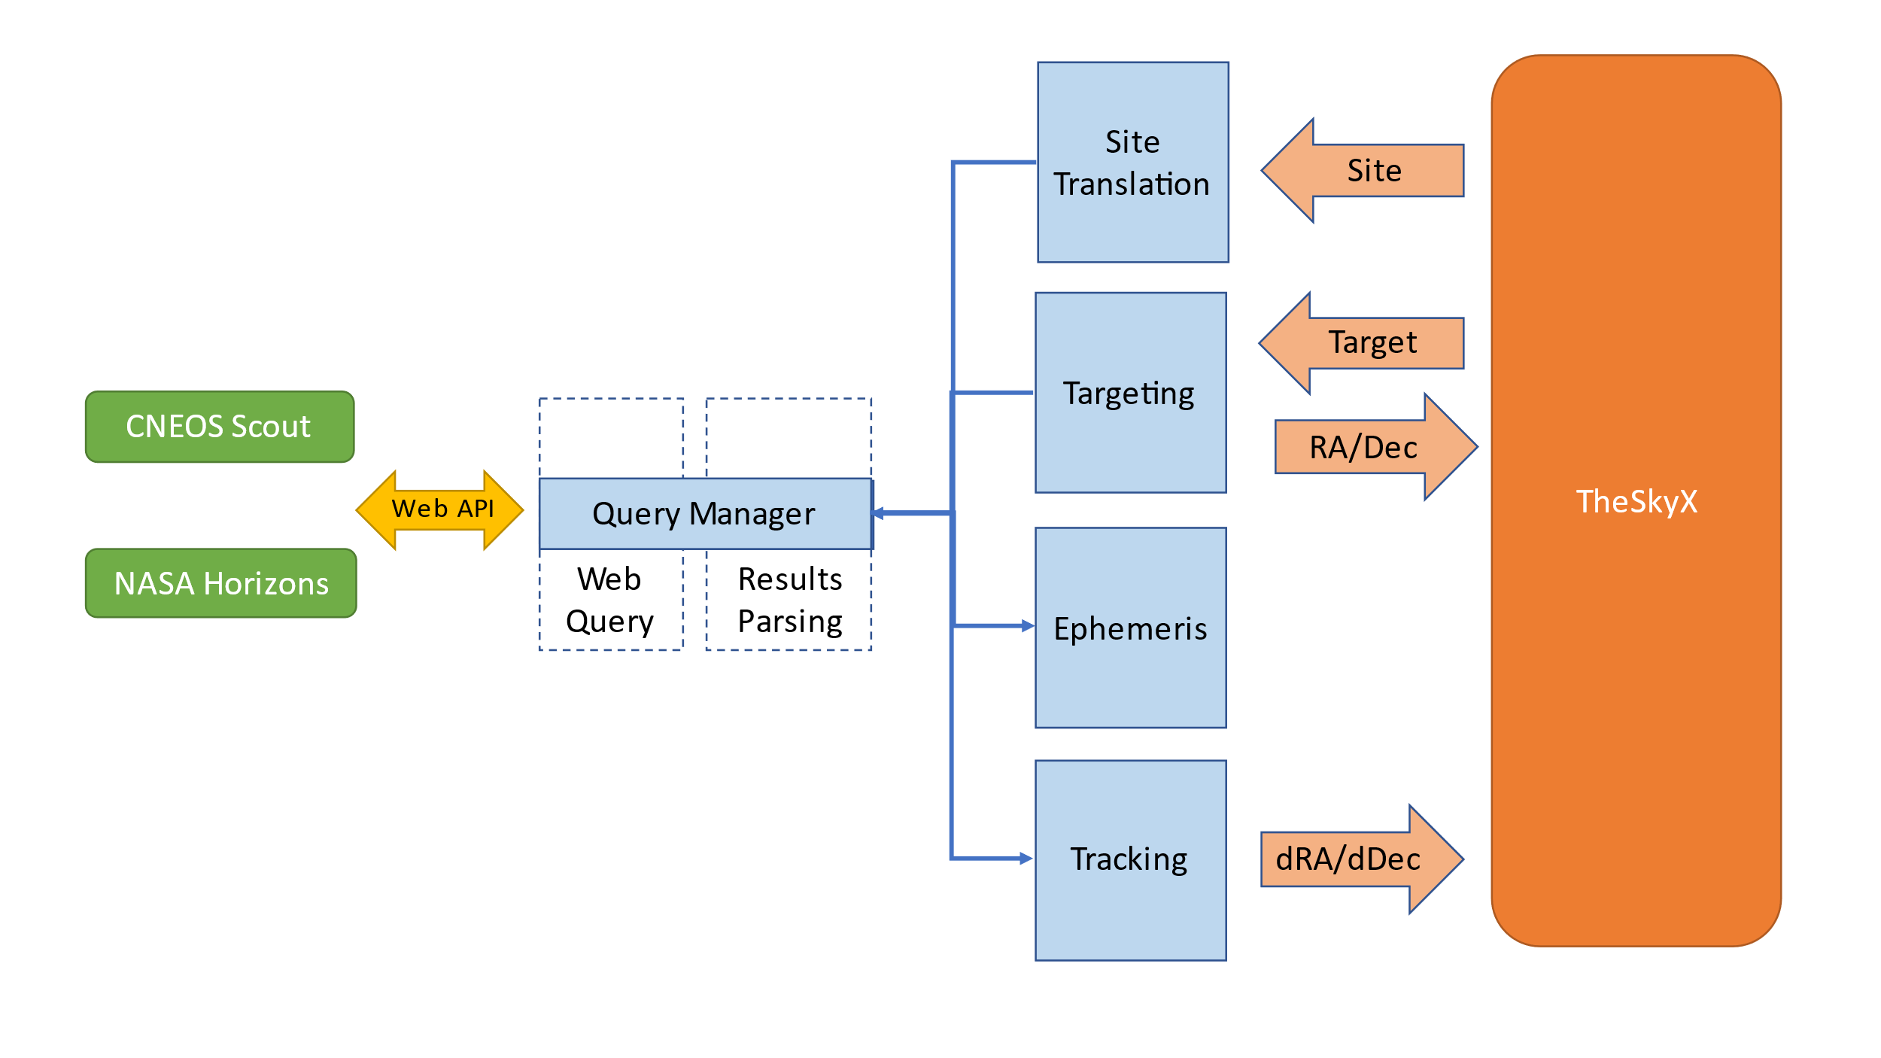

**Operation**

**Site Translation**

The Scout query does not support ephemeris based on arbitrary latitude/longitude site location. Ephemeris is only calculated for the set of Minor Planet Center (IAU) listed observatory sites, but there are a lot of them. To get site specific ephemeris, Hot Pursuit translates the ephemeris for the nearest observatory to the user’s site. This translation is applied to both the position of the target (RA/Dec) and tracking rate (dRA/dDec) as viewed from the user’s site.

If the ephemeris acquired from Horizons, then the translation is unnecessary as Horizons will compute ephemeris based on the specific location (lat, long, elev) of the observer.

**Requirements**

Hot Pursuit is a Windows Forms executable, written in Visual C#. The app requires TheSkyX Imaging Edition (Build 10966 or later). The application runs as an uncertified, standalone application under Windows 10 (also Win 8, maybe).

**Installation**

As of this writing, the installation packages for Hot Pursuit are available on GitHub in the “publish” directory of rrskybox/Hot-Pursuit.

Download the HotPursuit.zip and extract. Run "setup.exe". The application is uncertified so Windows may object. If so, click on “More Info”, then “Run Anyway”. Upon completion, an application icon will have been added to the start menu under "TSXToolKit" with the name "Hot Pursuit". This application can be pinned to the Start if desired.

Note, after the installation of any new TheSky build, the user must launch TheSky once in Administrator Mode in order to allow TheSky to register its interface libraries.

**Support**

This application was written for the public domain and as such is unsupported. The developer would happily entertain questions or suggestion and may update the application occasionally as time permits. Otherwise, the developer wishes you his best and hopes everything works out but recommends learning Visual C# (it's not hard and the tools are free from Microsoft) if you find a serious problem or want to add features. The source is supplied as a Visual Studio 2019 project on GitHub

**Appendix 1: Image Calibration Library Set Up**

Hot Pursuit requires Noise Reduction (Calibration) folders that have the format:

B<b>_T<t>_E<e>_F<f>

where

*<b>* = binning: “1x1”, “2x2”, etc

*<t>* = temperature in Centigrade: “-x.x”

*<e>* = exposure in seconds: “e.ee”

*<f>* = filter name: “C”, “R”, “B”, “V”, etc

Examples

“B1x1_T-20.2_E35.00_FC”

“B2x2_T-10.0_E180.00_FR”

This format enables Hot Pursuit to select the correct image reduction folder based on each image exposure and filter.

The easiest way to prepare for a full reduction library, is to use the TSXToolKit utility *Reduction Library Generator* which can be downloaded from GitHub/rrskybox/Reduction Library Generator in same manner as Hot Pursuit itself. This utility will parse a directory and subdirectories for reduction files, compile their paths into the folder structure and naming conventions, then directly modify the TheSky configuration file to accept the libraries. TheSky must be restarted once to load the library structure.